# Practical 7: CRUD operations using Neo4j

**Create Person, City, and Hobby Nodes**

// Create Person nodes

CREATE (:Person {name: 'Alice', age: 30})

CREATE (:Person {name: 'Bob', age: 35})

CREATE (:Person {name: 'Charlie', age: 28})

// Create City nodes

CREATE (:City {name: 'London'})

CREATE (:City {name: 'New York'})

CREATE (:City {name: 'Paris'})

// Create Hobby nodes

CREATE (:Hobby {name: 'Reading'})

CREATE (:Hobby {name: 'Hiking'})

CREATE (:Hobby {name: 'Painting'})

**Define Relationships**

// Define relationships

// Alice lives in London and likes Reading

CREATE (alice)-[:LIVES_IN]->(london)

CREATE (alice)-[:LIKES]->(reading)

// Bob lives in New York and likes Hiking

CREATE (bob)-[:LIVES_IN]->(newYork)

CREATE (bob)-[:LIKES]->(hiking)

// Charlie lives in Paris and likes Painting

CREATE (charlie)-[:LIVES_IN]->(paris)

CREATE (charlie)-[:LIKES]->(painting)

**Added 9 labels, created 18 nodes, set 12 properties, created 6 relationships, completed after 6 ms.**

### Add New Nodes and Relationships

// Create a new person

CREATE (:Person {name: 'David', age: 25})

// Create a new city

CREATE (:City {name: 'Berlin'})

// Create a new hobby

CREATE (:Hobby {name: 'Gardening'})

// Create a relationship: David lives in Berlin and likes Gardening

CREATE (david)-[:LIVES_IN]->(berlin)

CREATE (david)-[:LIKES]->(gardening)

**Added 3 labels, created 6 nodes, set 4 properties, created 2 relationships, completed after 21 ms.**

### Retrieve Data

// Retrieve all persons

MATCH (p:Person)

RETURN p

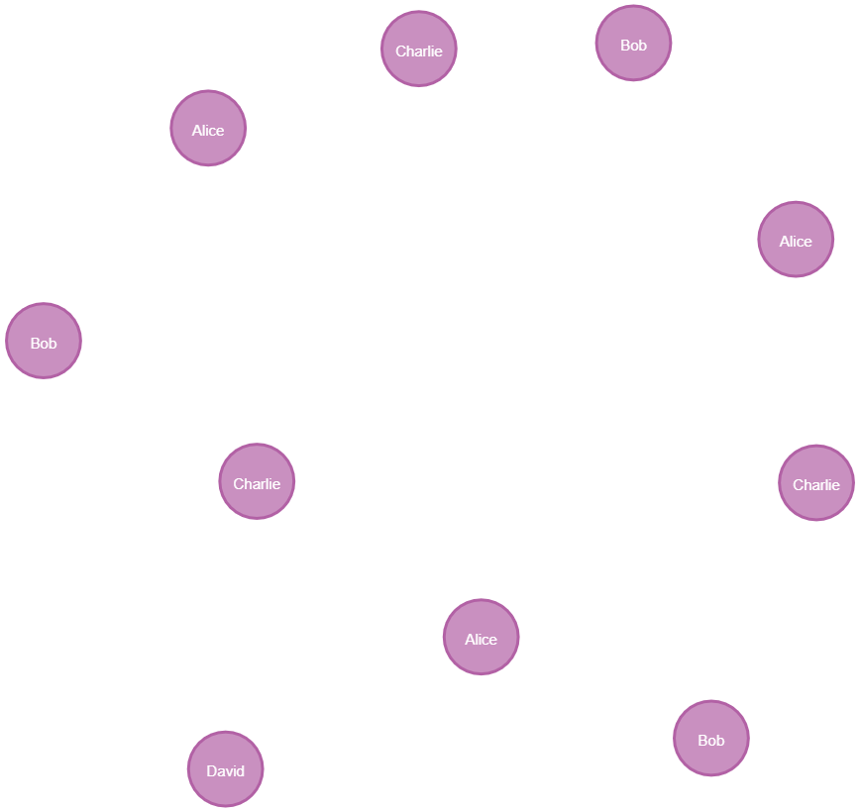

// Retrieve all cities

MATCH (c:City)

RETURN c

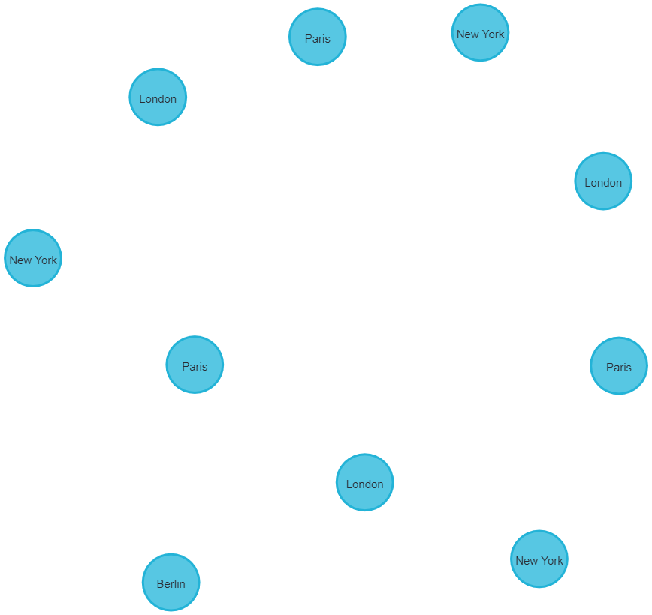

// Retrieve all hobbies

MATCH (h:Hobby)

RETURN h

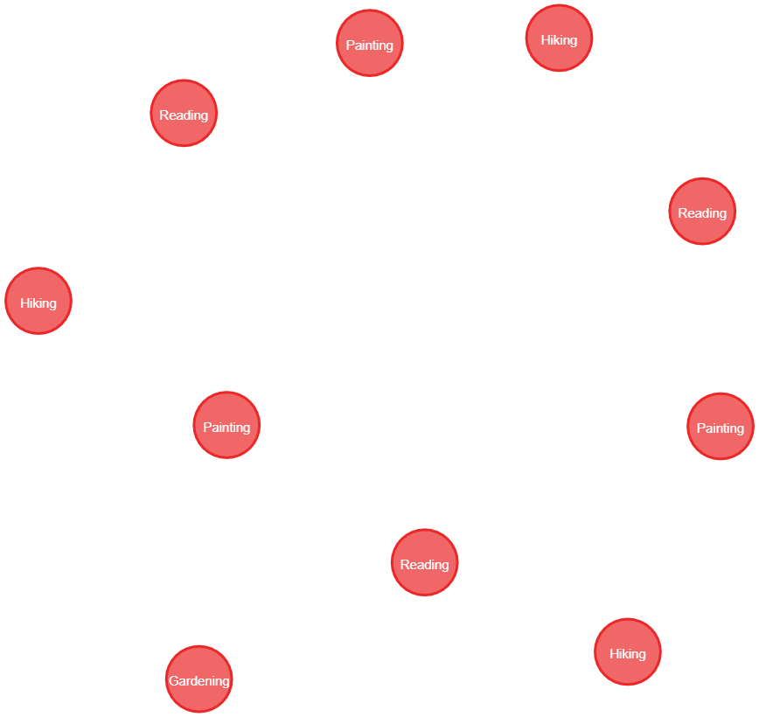

MATCH (n)

OPTIONAL MATCH (n)-[r]->(m)

RETURN n, r, m

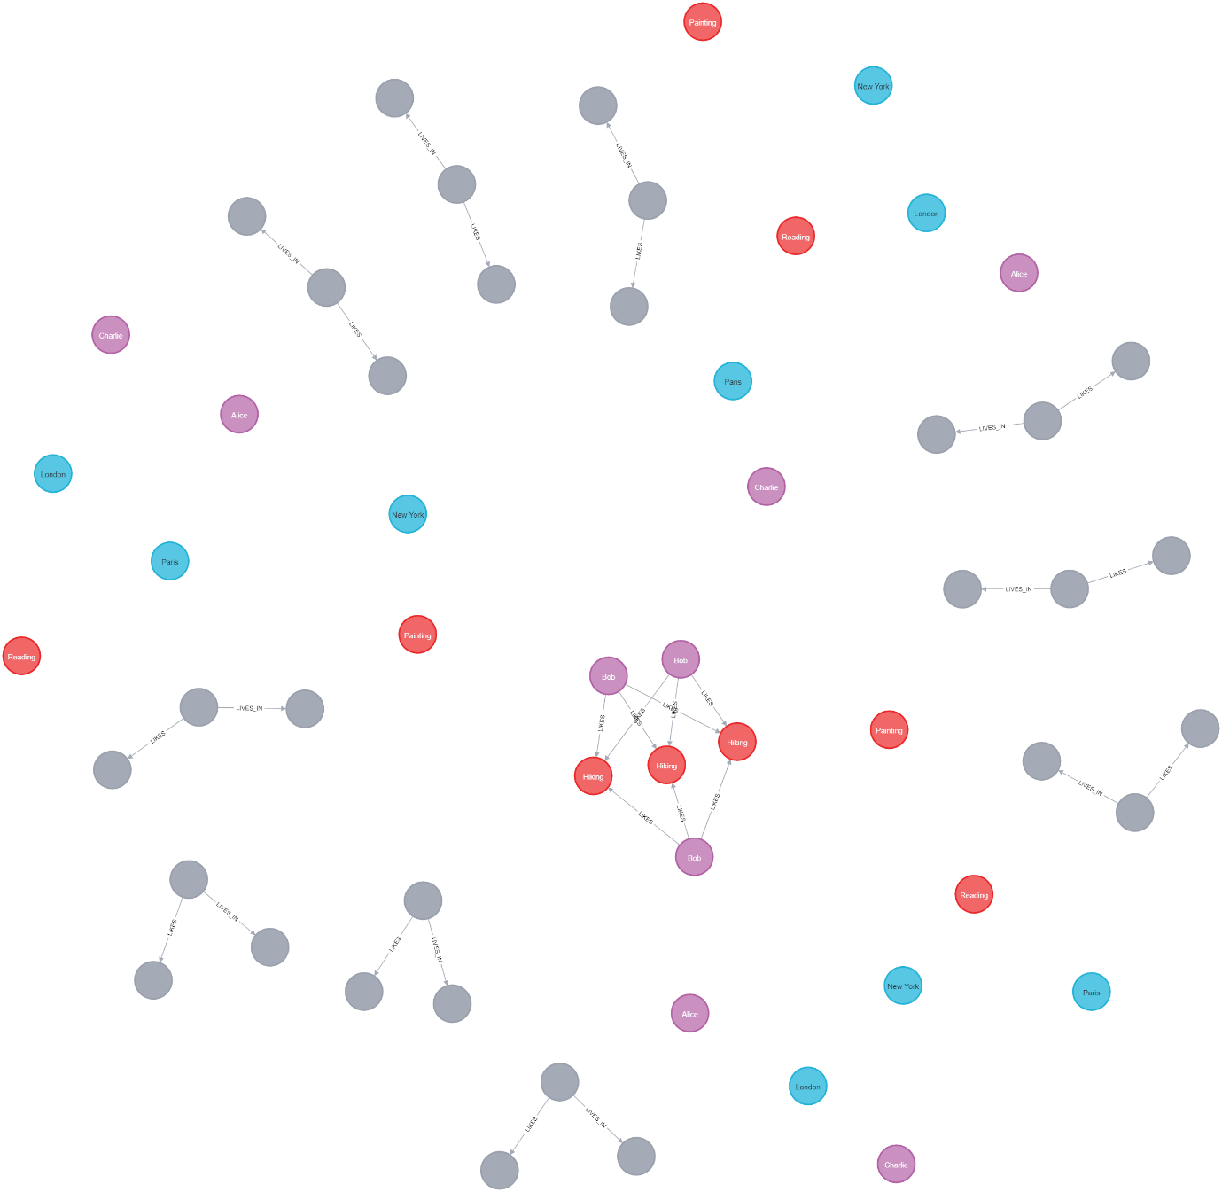

### Update Data

// Update Alice's age

MATCH (alice:Person {name: 'Alice'})

SET alice.age = 31

**Set 3 properties, completed after 31 ms.**

### Modify Relationships

// Add a new hobby for Bob

MATCH (bob:Person {name: 'Bob'})

MERGE (hiking:Hobby {name: 'Hiking'})

CREATE (bob)-[:LIKES]->(hiking)

**Created 9 relationships, completed after 26 ms.**

### Delete Nodes and Relationships

// Delete a specific person (e.g., David) and all relationships associated with them

MATCH (david:Person {name: 'David'})

DETACH DELETE david

**Deleted 1 node, completed after 15 ms.**

// Delete a specific city (e.g., Berlin) and all relationships associated with it

MATCH (berlin:City {name: 'Berlin'})

DETACH DELETE berlin

**Deleted 1 node, completed after 15 ms.**

// Delete a specific hobby (e.g., Gardening) and all relationships associated with it

MATCH (gardening:Hobby {name: 'Gardening'})

DETACH DELETE gardening

**Deleted 1 node, completed after 17 ms.**